TÉTELEK
- Environmental problems in Hungary.
- Describe the urban problems in developing and developed countries.
- Hydro-conflicts in the Carpathian Basin.
- Describe the role of climate in karst formation.
- Examine the problems of living in periglacial environments.
- Describe the problems and remedies of soil erosion by wind.
- Assess the likely consequences of a rising sea level during the present century for coastal landforms.
- How does ice fashion landforms?
ÁBRÁK
- Hévíz – geologic structure
- Earthquakes
- Soil profile
- Saltation
- Landforms produced by alpine glaciers
- El Niño, La Niña
- FDI inflows
- UHI

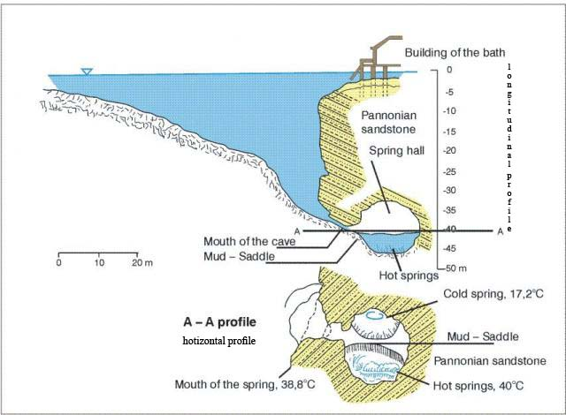
Figure 1

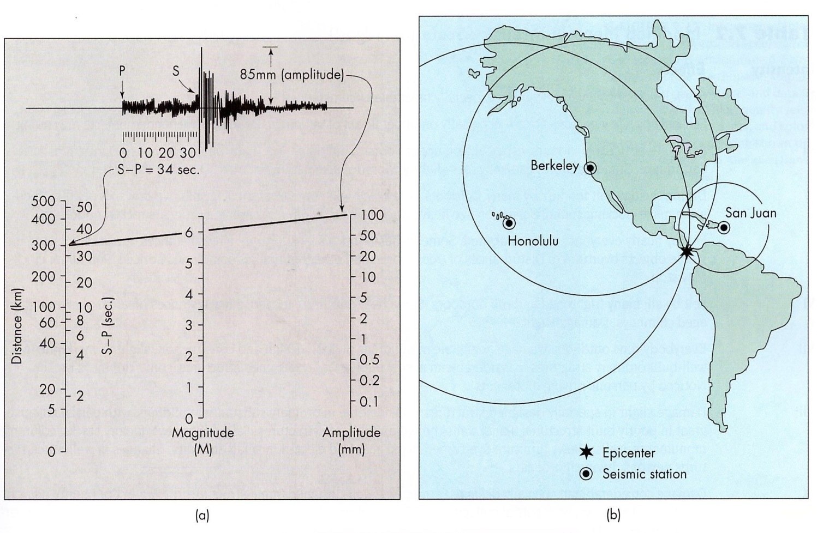
Figure 2

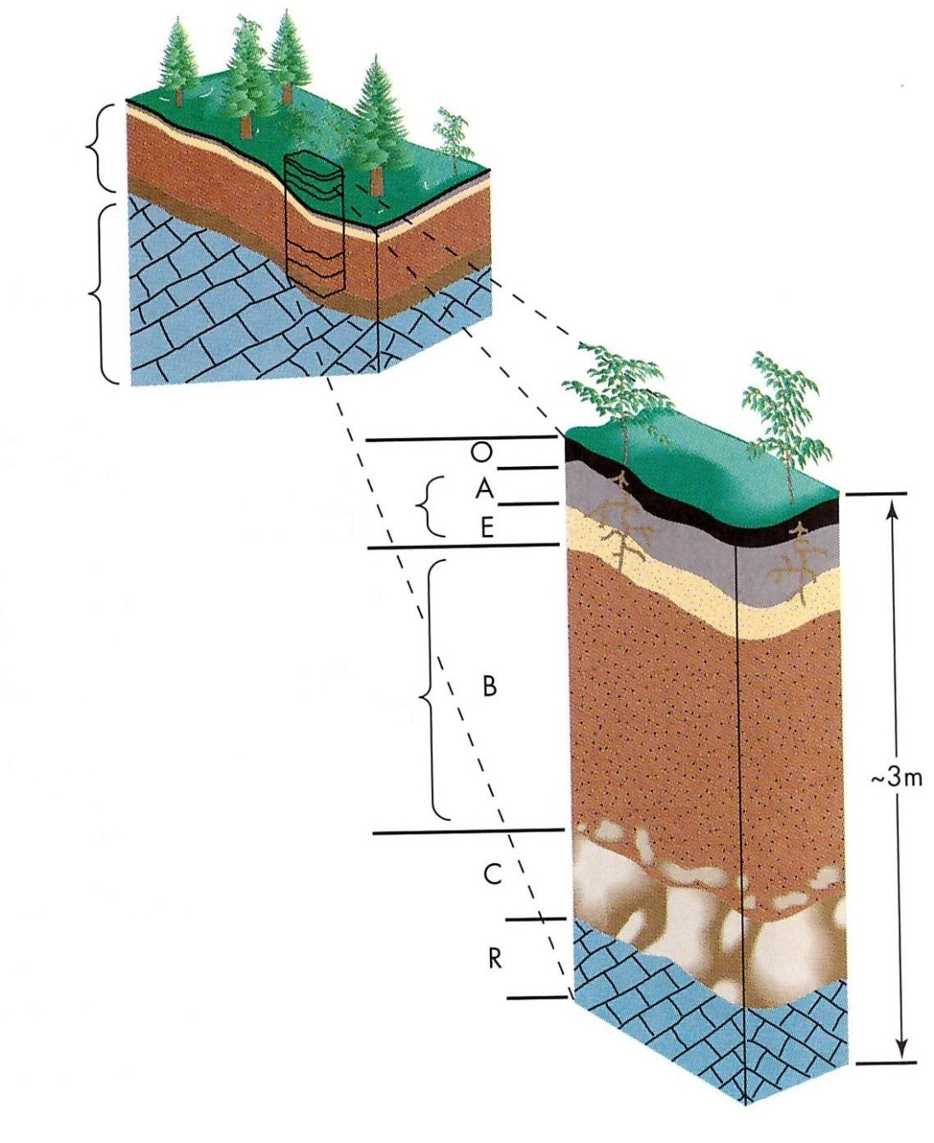
Figure 3

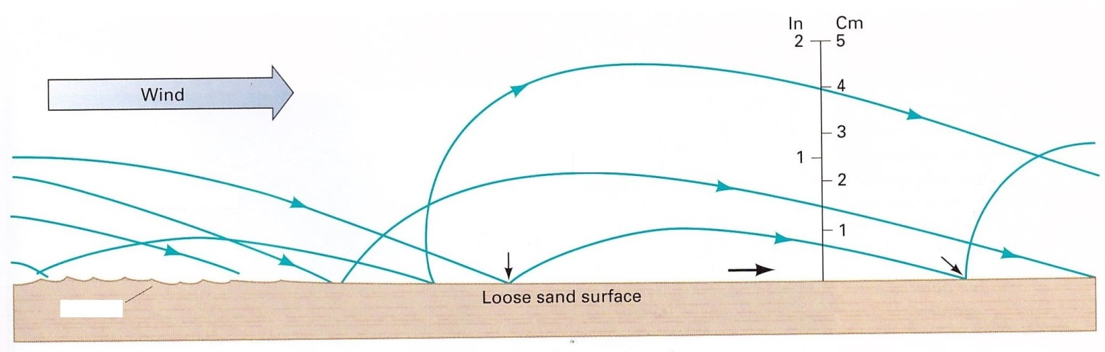
Figure 4

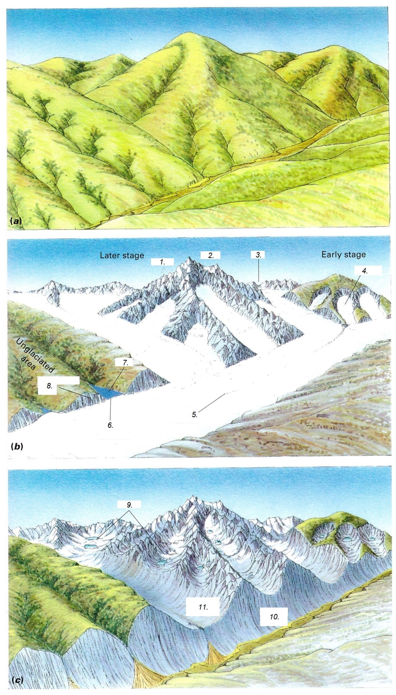
Figure 5
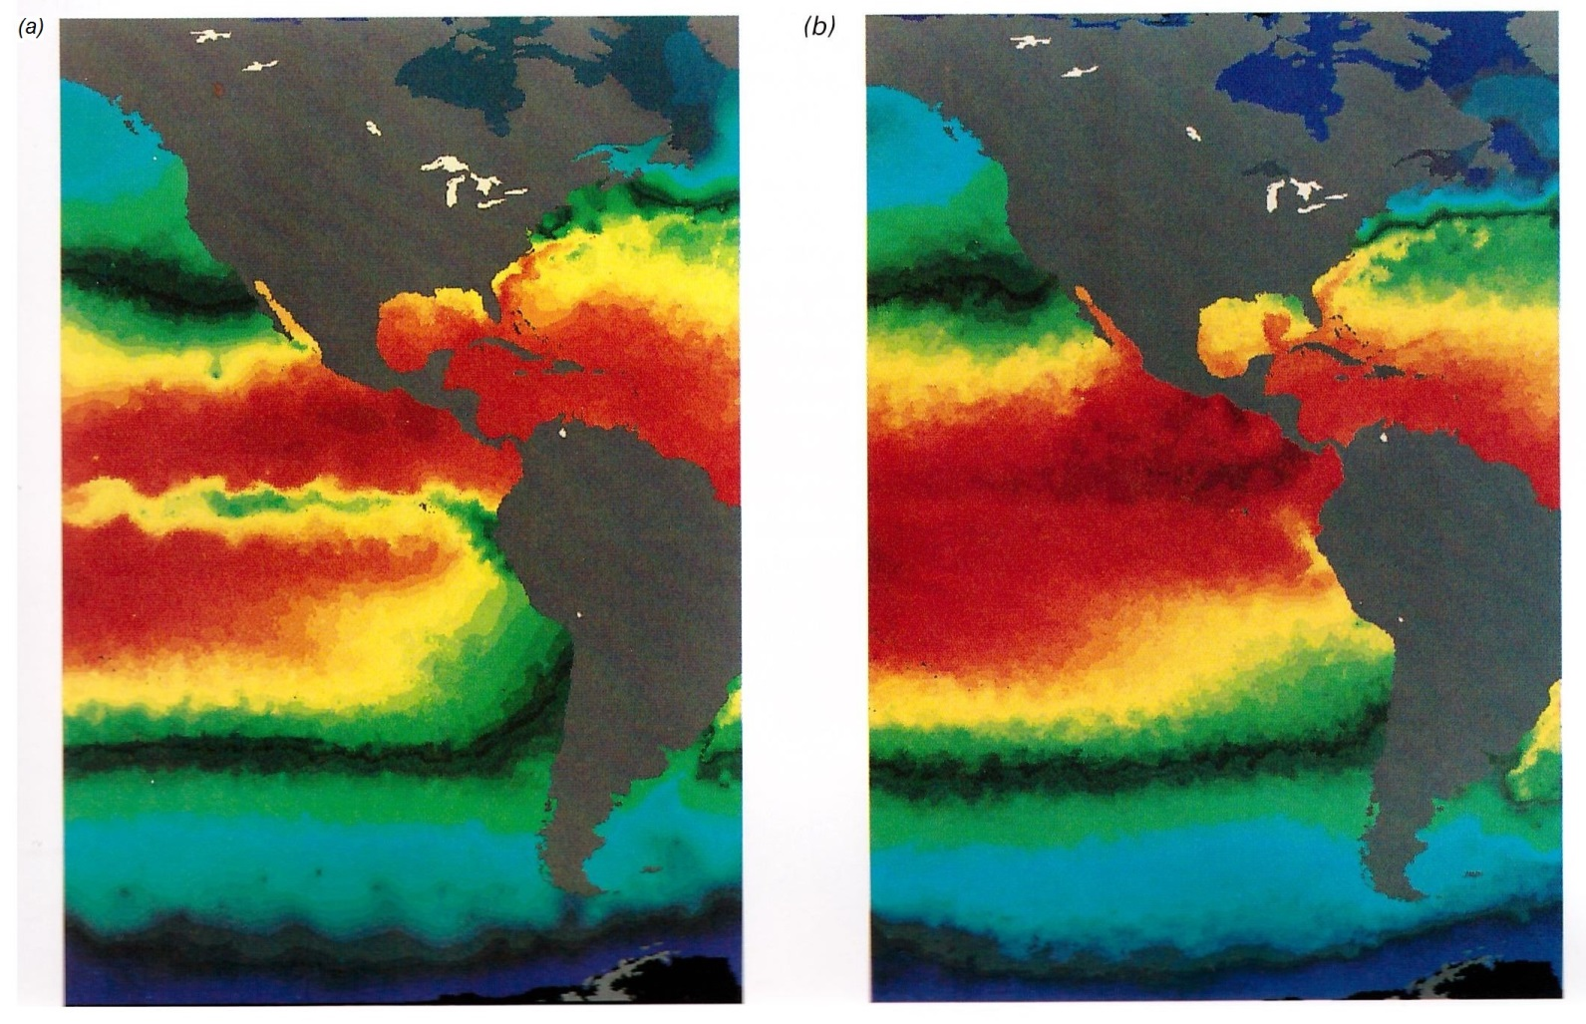
Figure 6

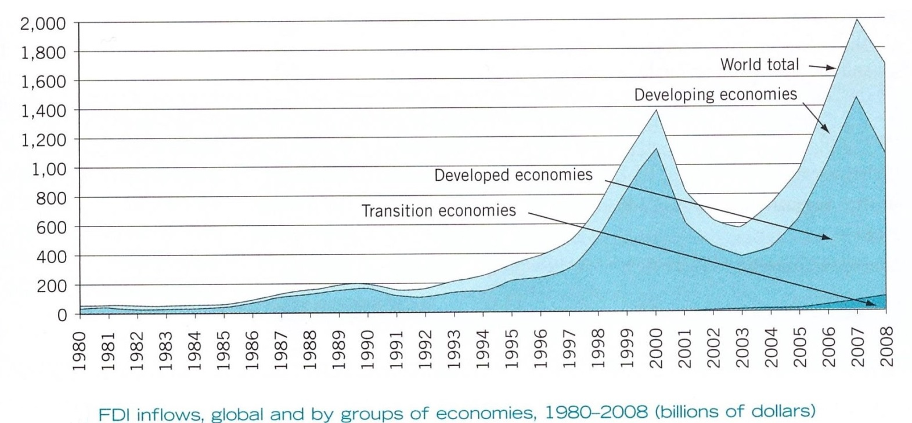
Figure 7

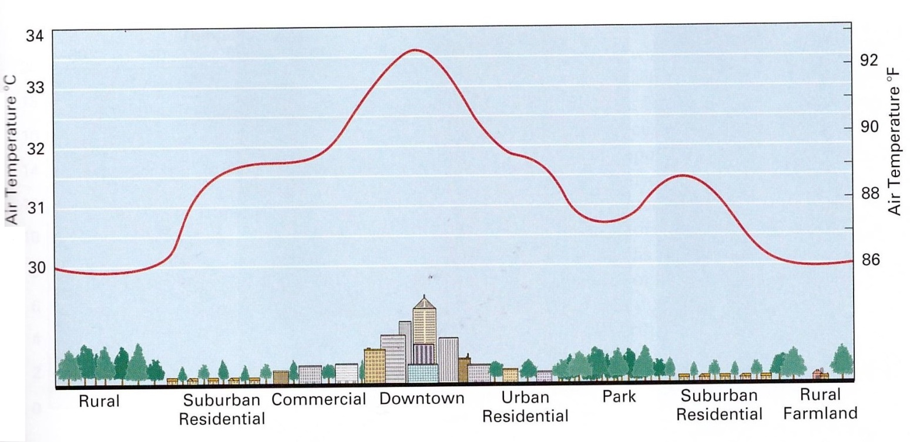
Figure 8

